**DBT Assignment 1**

Name : Mohul Y P

SRN : PES1UG22CS360

b)**select and count queries on “clubs” table**

**SELECT * FROM Clubs;**

**SELECT COUNT(*) FROM Clubs;**

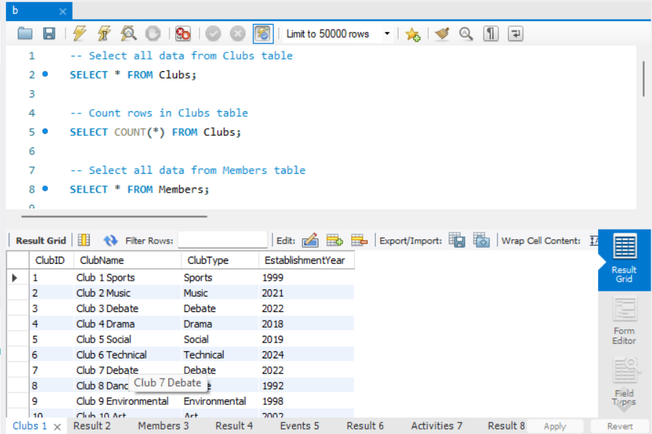

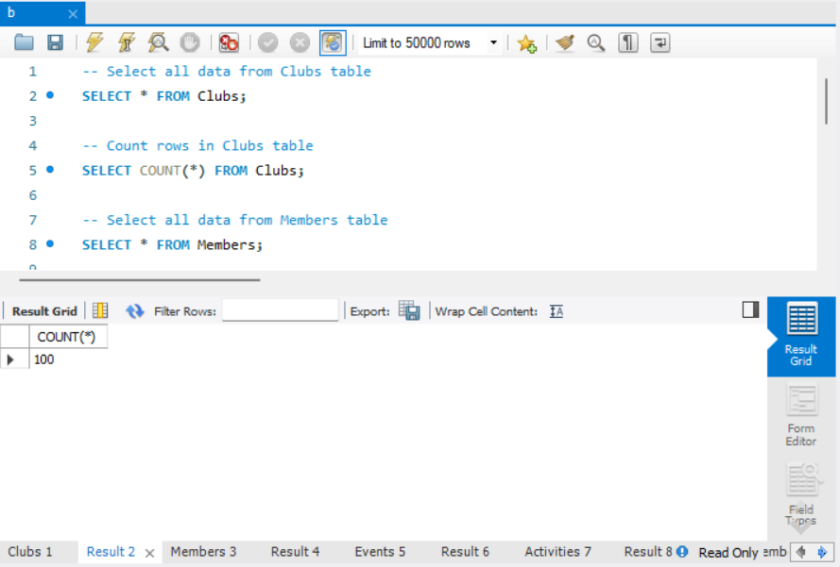

**select and count queries on “member” table**

**SELECT * FROM Members;**

**SELECT COUNT(*) FROM Members;**

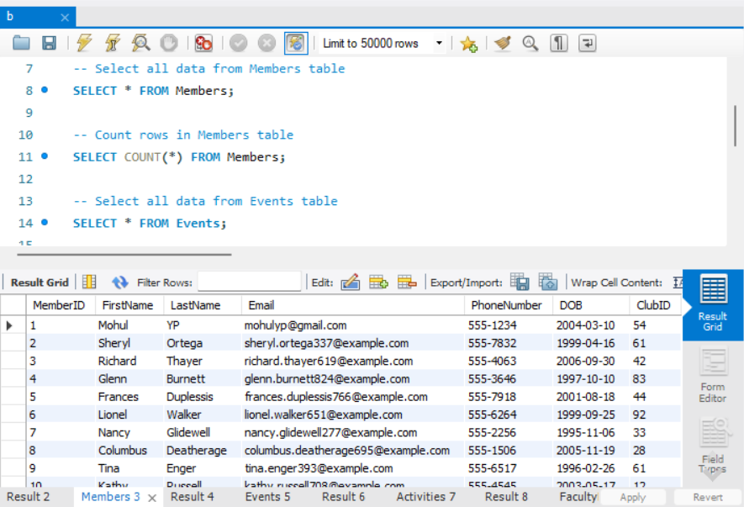

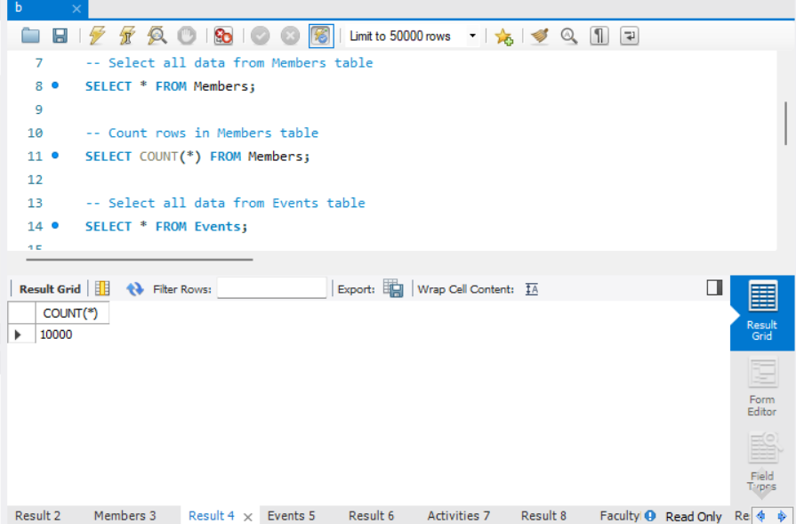

**select and count queries on “events” table**

**SELECT * FROM Events;**

**SELECT COUNT(*) FROM Events;**

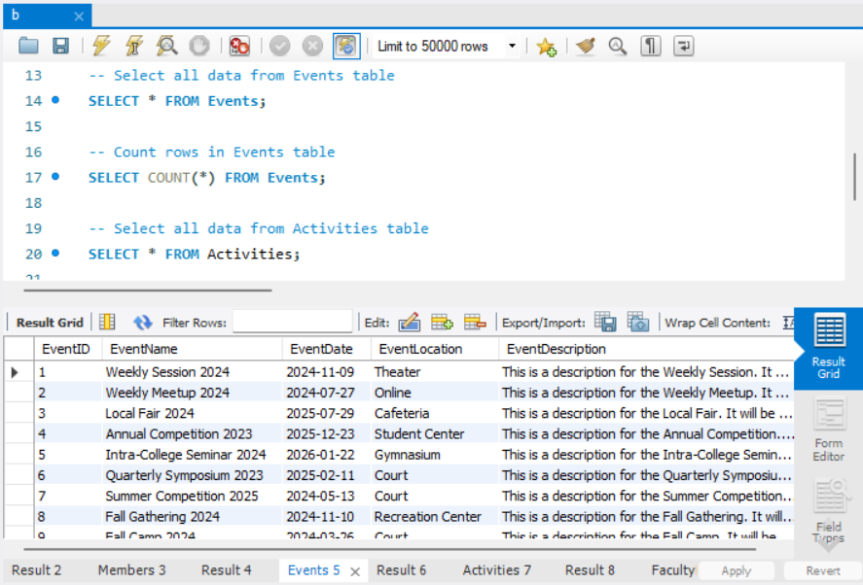

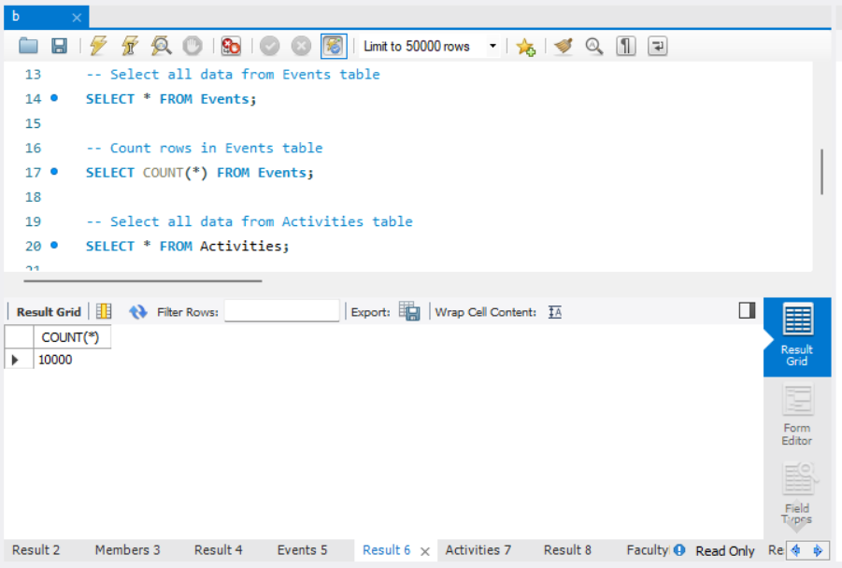

**select and count queries on “activities” table**

**SELECT * FROM Activities;**

**SELECT COUNT(*) FROM Activities;**

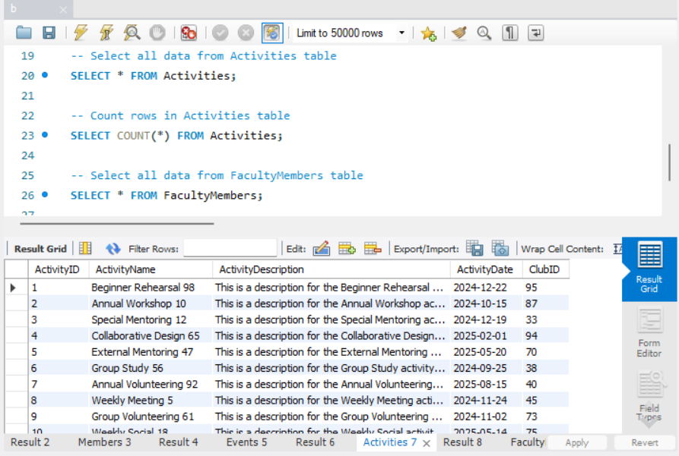

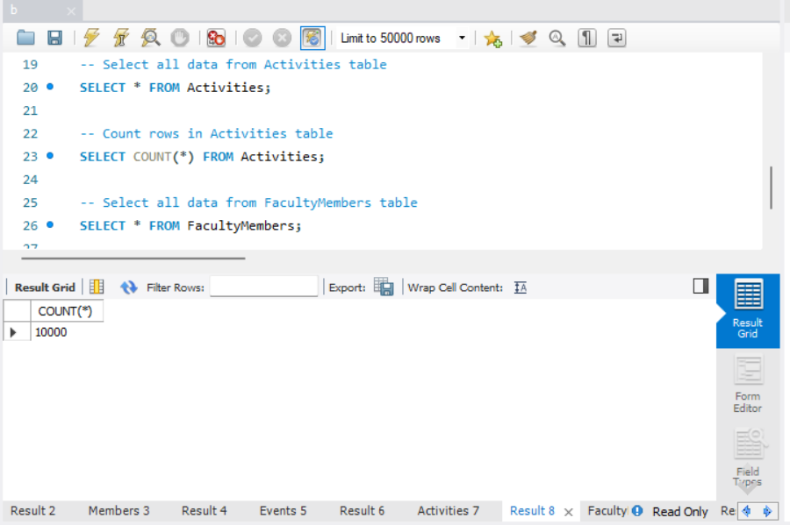

**select and count queries on “faculty members” table**

**SELECT * FROM FacultyMembers;**

**SELECT COUNT(*) FROM FacultyMembers;**

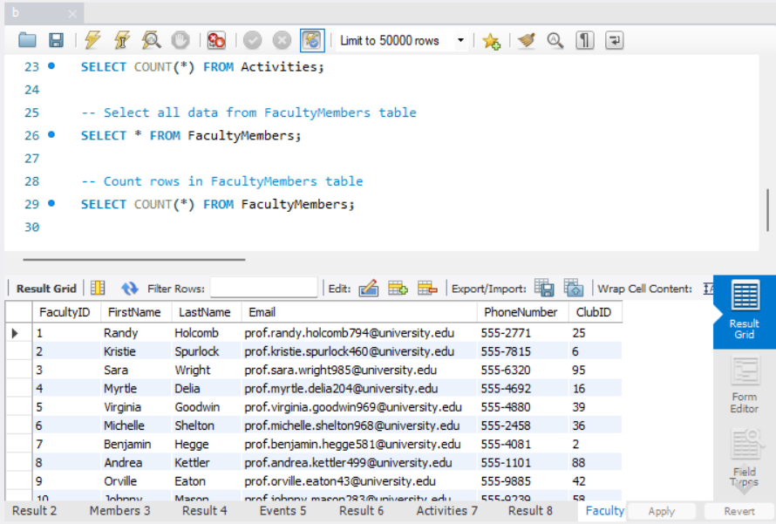

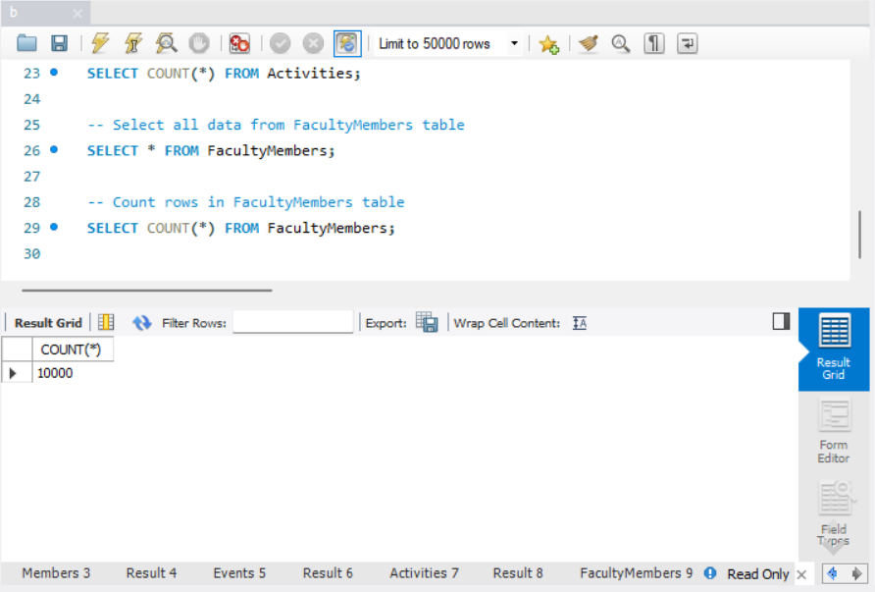

**INDEX SCAN**

**1)SELECT FirstName, LastName, Email**

**FROM Members**

**WHERE ClubID = 1;**

Expected Behavior: ClubID is indexed(primary key), this query will use an index scan to find the matching Members rows based on the ClubID value.

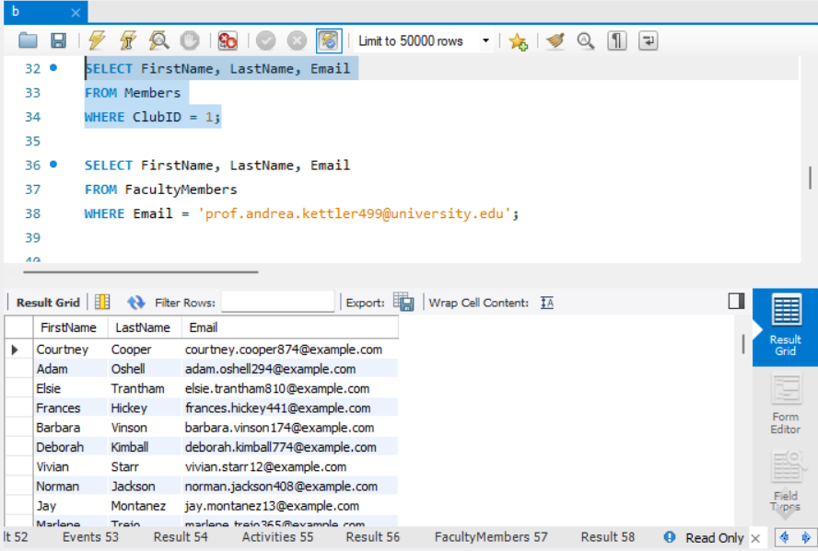

**2)**

**SELECT FirstName, LastName, Email**

**FROM FacultyMembers**

**WHERE Email = 'prof.andrea.kettler499@university.edu';**

**Expected Behavior: Since Email is unique, the query will benefit from an index scan on the Email column to quickly find the matching row.**

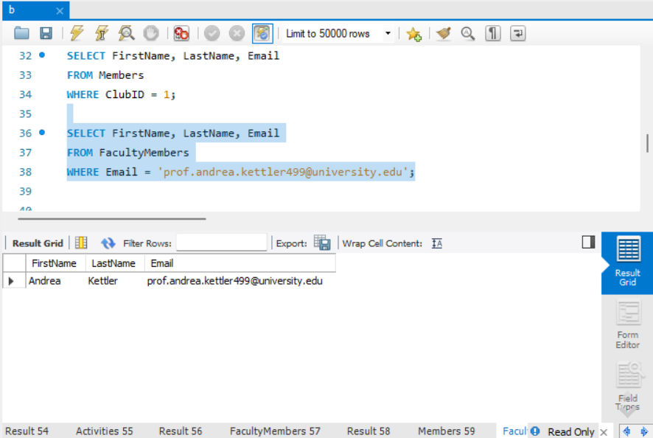

**TABLE SCAN**

1. **SELECT * FROM Clubs; (no filters or indexes are used)**

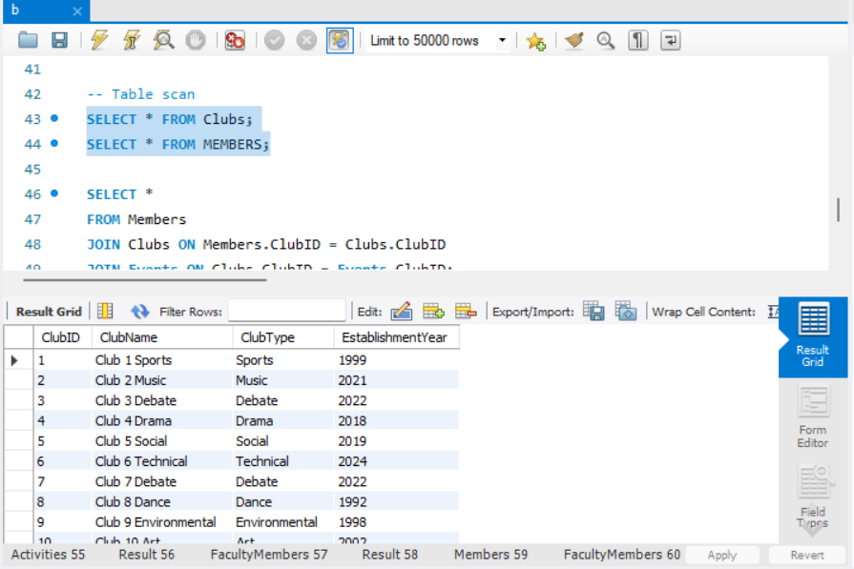

1. **SELECT * FROM MEMBERS;(no filters or scans used)**

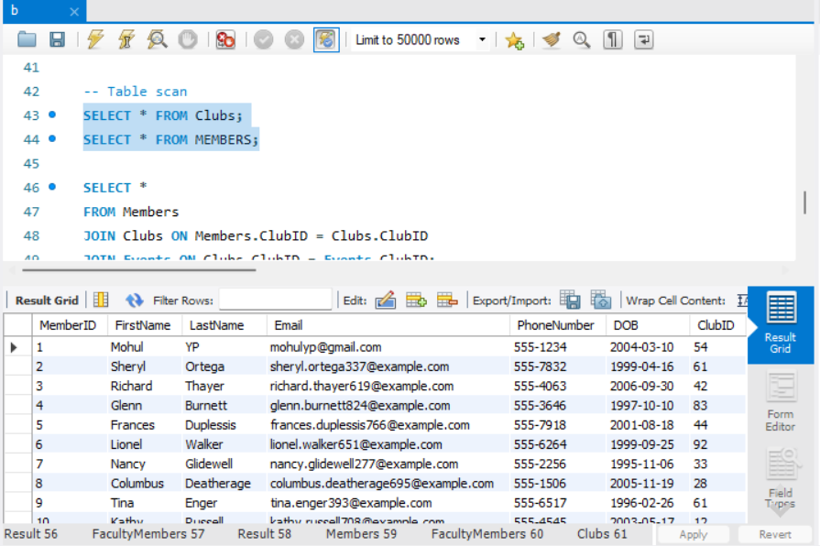

**queries with multi-table joins involving 3 tables; including both "SELECT *" and**

**conditional "SELECT" queries with a subset of columns.**

**1)**

**SELECT \***

**FROM Members**

**JOIN Clubs ON Members.ClubID = Clubs.ClubID**

**JOIN Events ON Clubs.ClubID = Events.ClubID;**

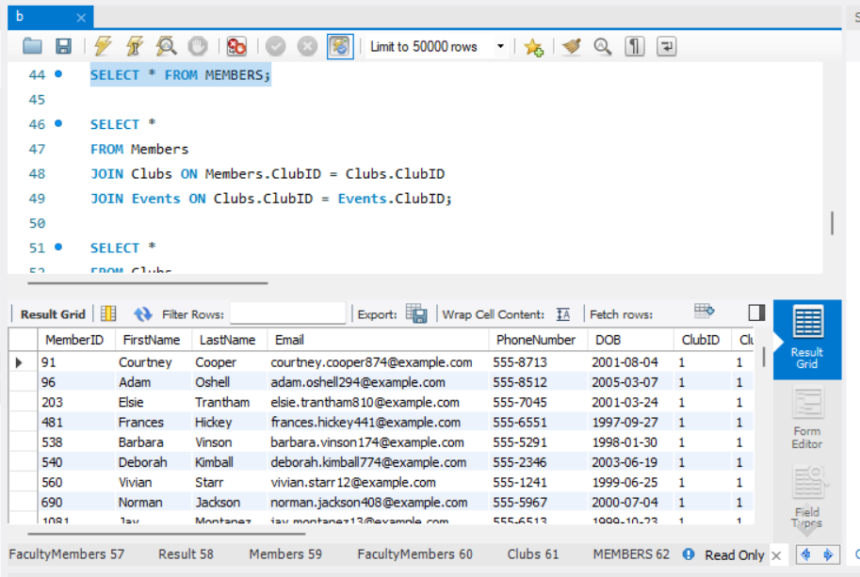

**2)**

**SELECT Members.FirstName, Members.LastName, Clubs.ClubName**

**FROM Members**

**JOIN Clubs ON Members.ClubID = Clubs.ClubID**

**WHERE Members.DOB > '2000-01-01';**

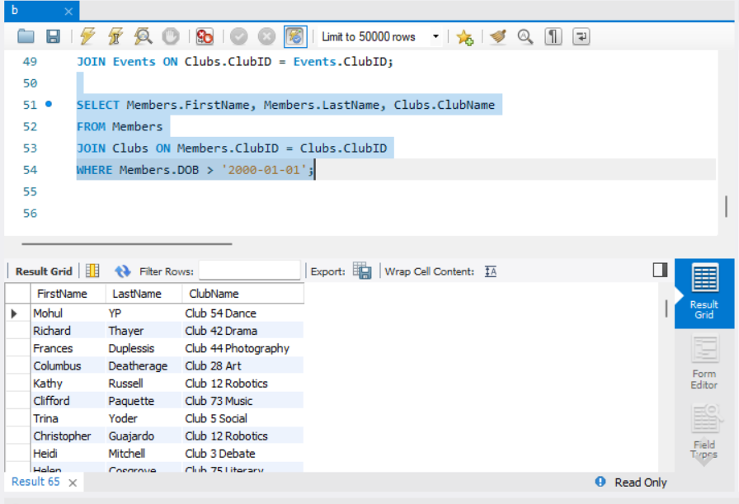

**EXPLAIN ANALYZE Each of the queries**

**1)** **EXPLAIN ANALYZE**

**SELECT FirstName, LastName, Email**

**FROM Members**

**WHERE ClubID = 1;**

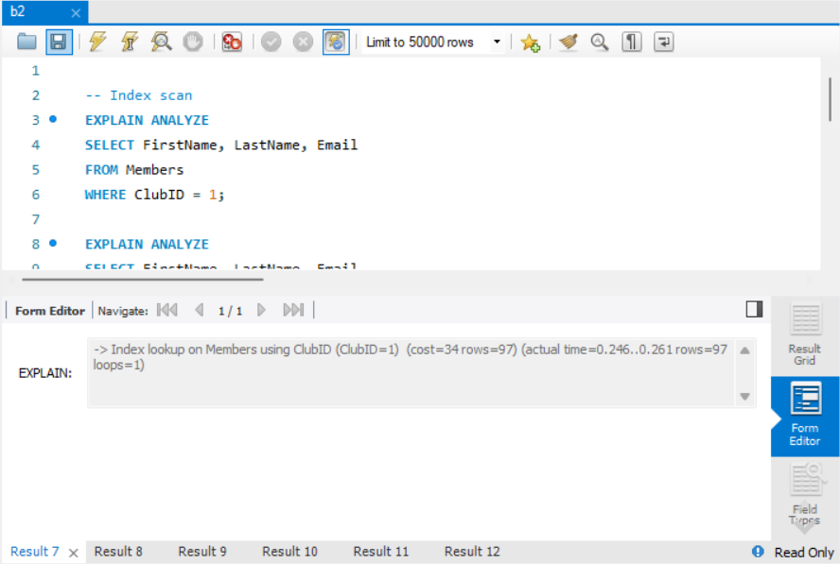

**The actual execution time was very low (0.246 to 0.261 milliseconds) because of index scan, and 97 rows were retrieved in one loop.**

**2)**

**EXPLAIN ANALYZE**

**SELECT FirstName, LastName, Email**

**FROM FacultyMembers**

**WHERE Email = 'prof.andrea.kettler499@university.edu';**

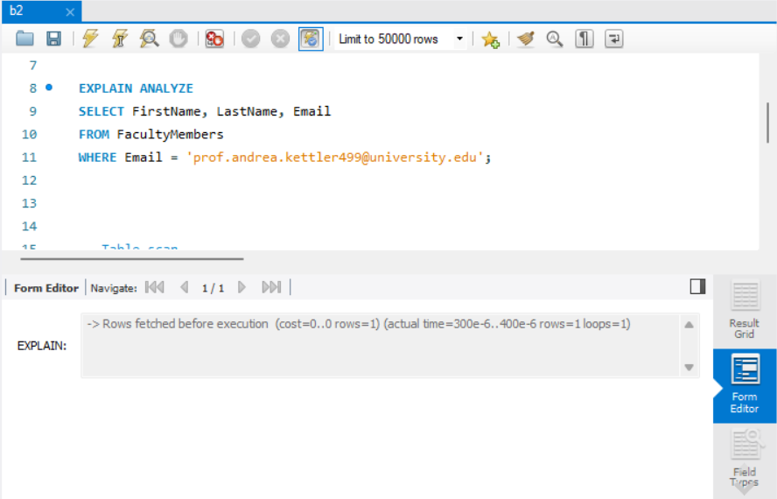

**(cost=0..0 rows=1): The planner estimated that it would only retrieve one row at zero cost.**

**actual time=300e-6..400e-6: The execution time is extremely small, in microseconds (300 to 400 microseconds).**

**3)**

**EXPLAIN ANALYZE**

**SELECT * FROM Clubs;**

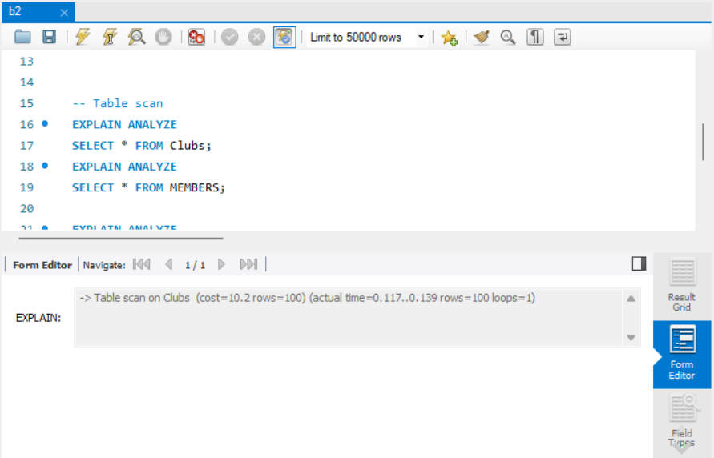

**cost=10.2 rows=100: The optimizer estimated a cost of 10.2 and expected to scan 100 rows.**

**actual time=0.117..0.139 rows=100 loops=1: The actual execution time is 0.117 to 0.139 ms, which is relatively low because the table is not that big.**

**4)** **EXPLAIN ANALYZE**

**SELECT * FROM MEMBERS;**

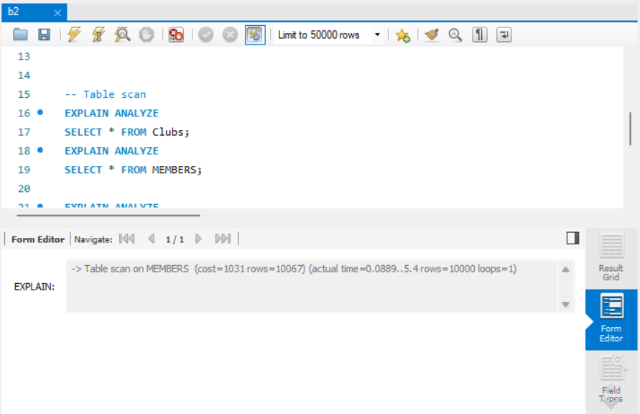

**cost=1031 rows=10067: The estimated cost of executing the query is 1031. The planner estimated that the table contains 10067 rows.**

**actual time=0.0889..5.4 : The execution time ranged from 0.0889 ms (start) to 5.4 ms (completion).**

**This query used a table scan, hence it performance is bad.**

**5)**

**EXPLAIN ANALYZE**

**SELECT \***

**FROM Members**

**JOIN Clubs ON Members.ClubID = Clubs.ClubID**

**JOIN Events ON Clubs.ClubID = Events.ClubID;**

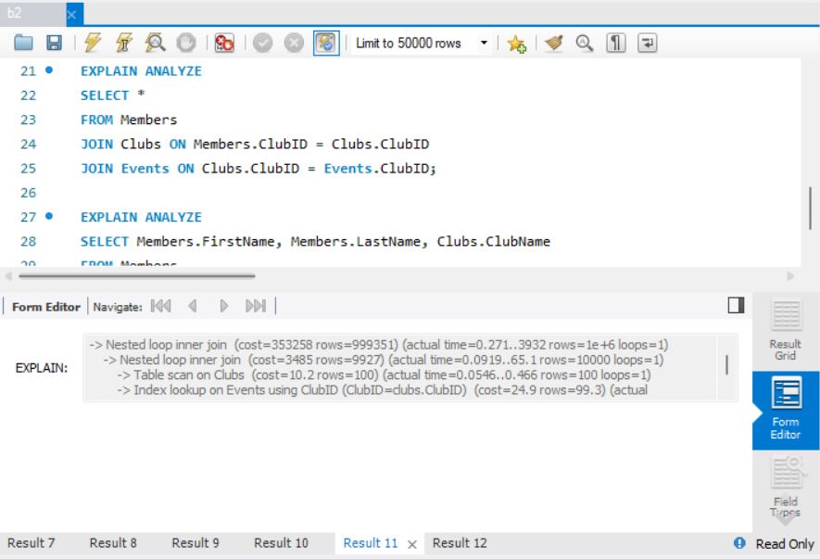

**6)**

**EXPLAIN ANALYZE**

**SELECT Members.FirstName, Members.LastName, Clubs.ClubName**

**FROM Members**

**JOIN Clubs ON Members.ClubID = Clubs.ClubID**

**WHERE Members.DOB > '2000-01-01';**

